**ShopNest Store Dashboard**

1. Identify the rating distribution in the Shop_Nest dataset, showcasing ratings categorized as Excellent, Very Good, Good, Bad, and Very Bad, along with corresponding orders.

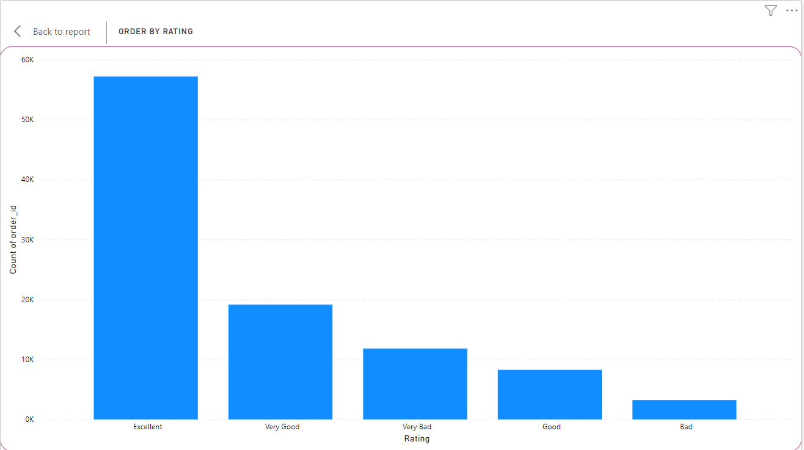

**Order by rating**

In this question I have created a new column name Rating where I transform the data using the if conditional loop formula after that I created a report view in which in the build visual ,in the x-axis I drag and drop rating and in y-axis count of order_id and I used the stacked column chart.

Formula of rating:

Rating = IF([review_score]==5,"Excellent",IF([review_score]==4,"Very good",IF([review_score]==3,"Good",IF([review_score]==2,"Bad",IF([review_score]==1,"Bad")))))

2.What are the top 10 and bottom 18 most popular product categories in the ShopNest dataset? Please list them based on the number of orders.

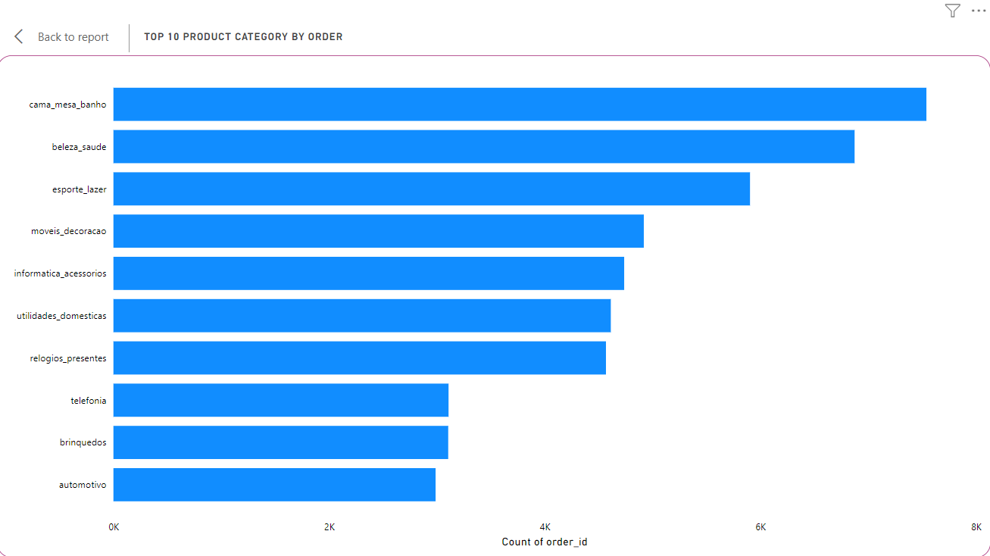**Top 10 product category name**

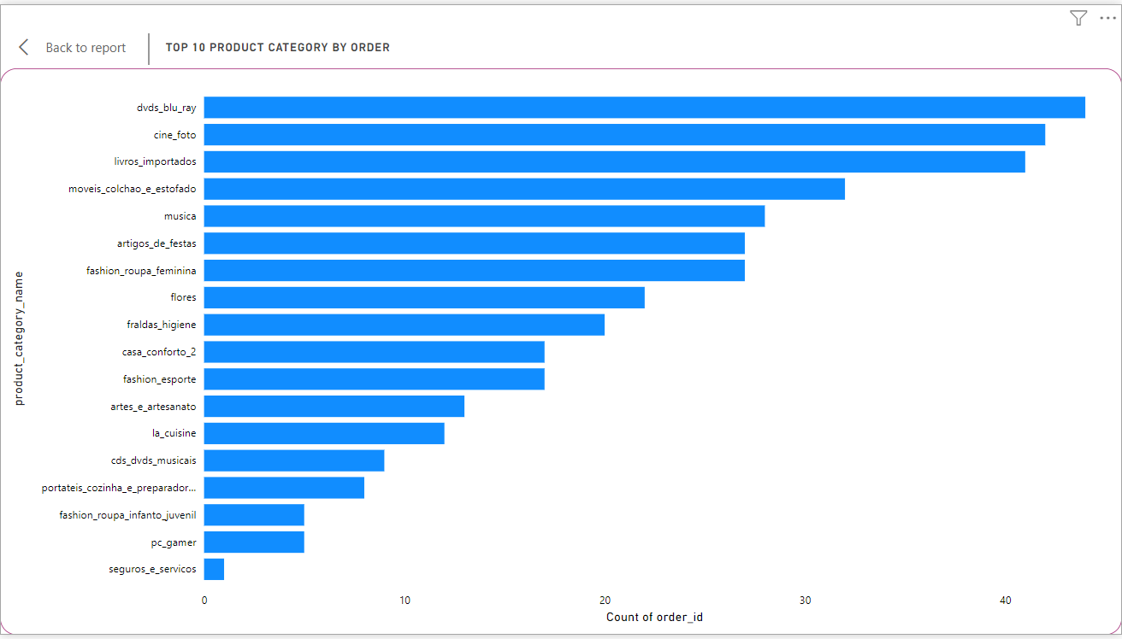

**Bottom 18 product category name**

In this question ,I merged two table i.e Nexusgoods_products_Dataset and Nexusgoods_order_items_dataset ,in report view in the x-axis drag and drop order_id and in y-axis product_category_name since in the question it is said to find the top 10 and bottom 18 so for that I have used filter in which I select top 10 and if I need to change it to bottom 18 I can change it from show items and I have used Stacked bar chart.

3. List the total number of active sellers by yearly and monthly.

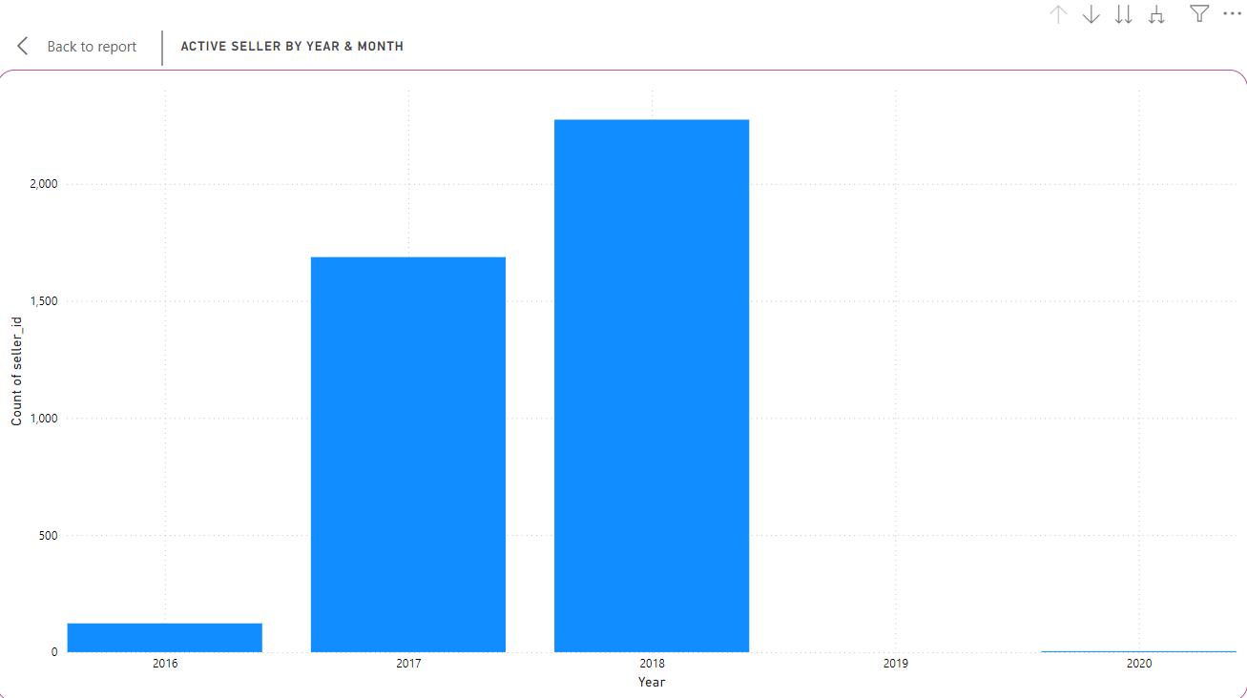

**Active seller by year**

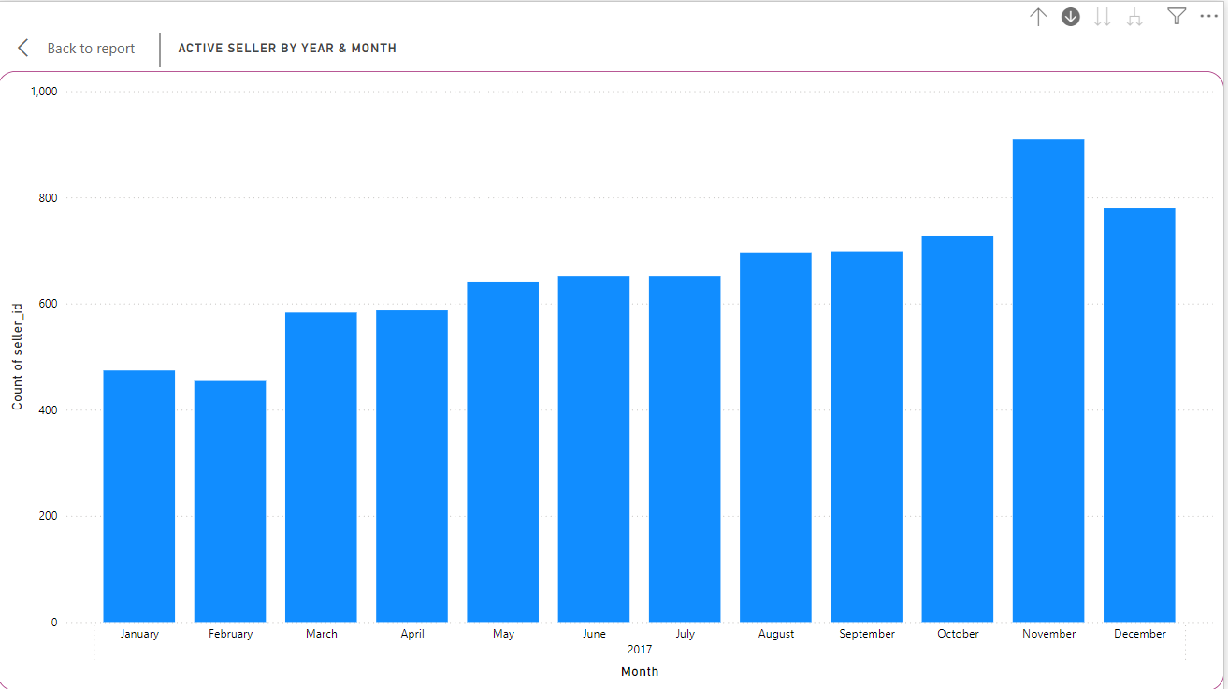

**Active seller by month**

In this question I am using the Nexusgoods_order_dataset,in the table view there is a column name shipping_limit_date I need to change data_type in date after which I need to make a report for which I used Stacked column chart where in x-axis is shipping_limit_date and y-axis is count of seller_id, have use the drill in which we can check month and year active seller.

4.Which payment methods are most commonly used by ShopNest customers.

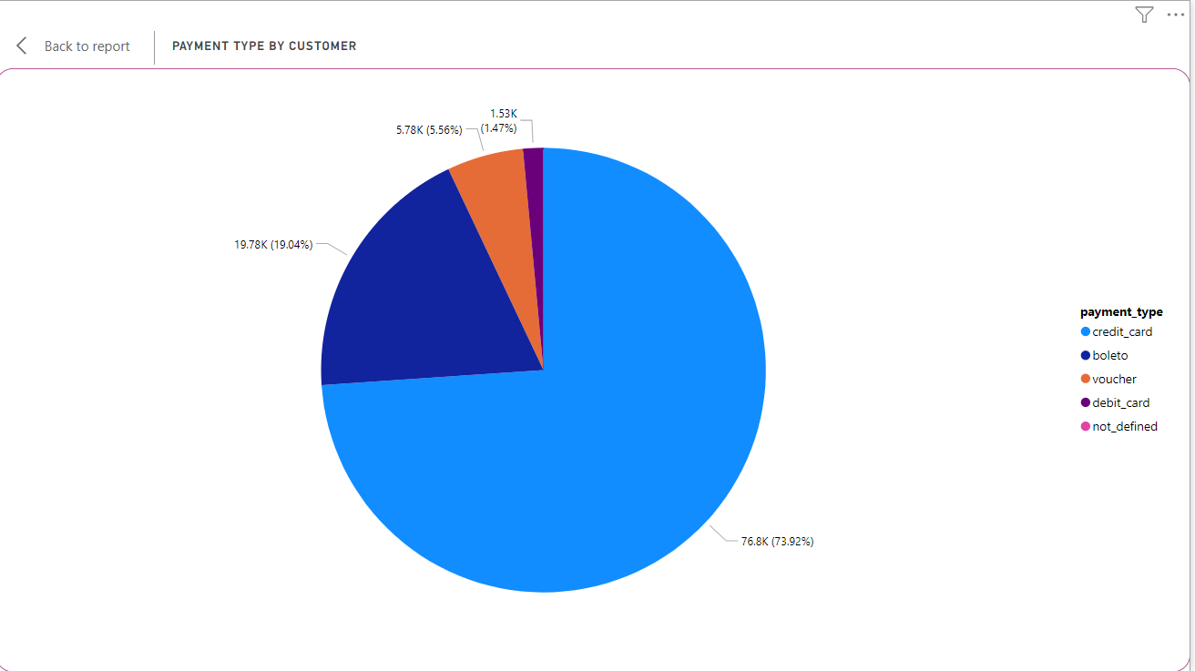

**Payment type by customer**

In this question ,I have used the table Nexusgoods_order_payments I have used Pie chart where I have put the payment type in legend and order_id in values.

6. Identify the product category. wise profit margin using the formula  
**Hint:** **(Payment value -price + Freight_value)/payment_value*100** (Rounded to two decimal points).

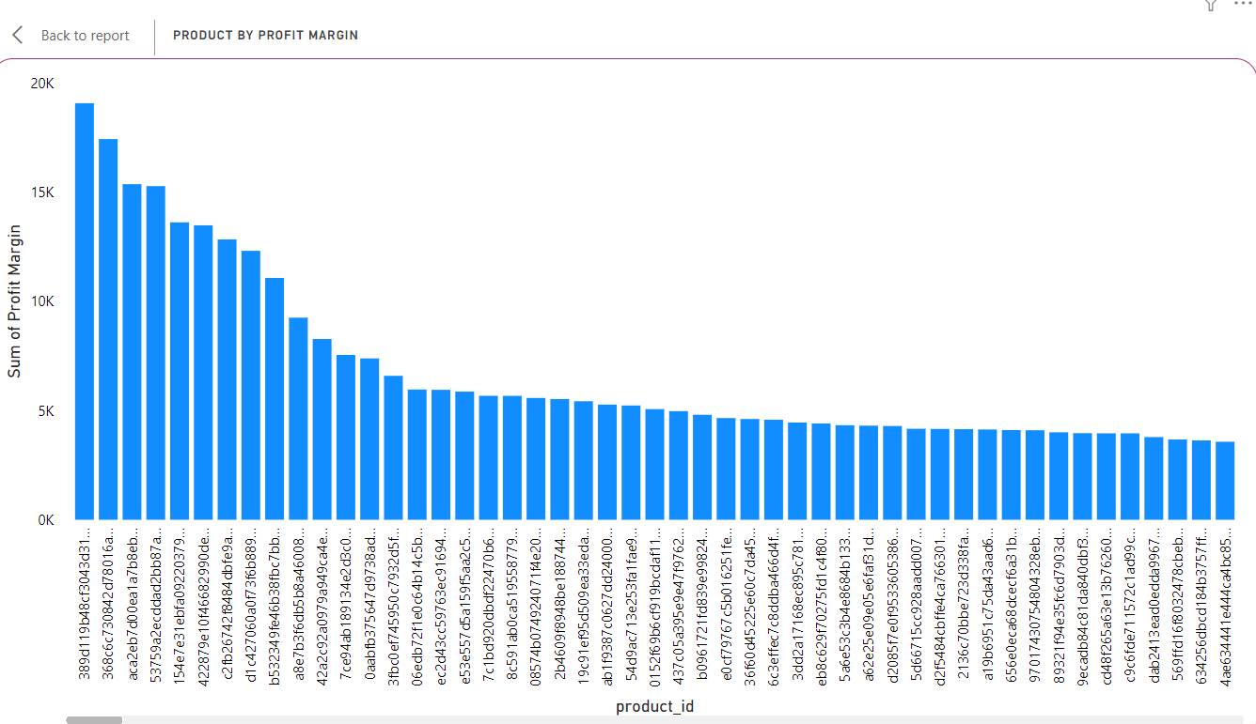

**Product by profit margin**

In this question I have to merge two dataset i.e Nexusgoods_orders_items_dataset and Nexusgoods_orders_payment_dataset ,I need to merge it because the payment value is not present in orders dataset and need to put the formula  **[(Payment value -price + Freight_value)/payment_value*100 ]** and create the column.In the visualizations in x-axis it is product_id and y-axis profit margin and used Stacked column chart.

6. Determine the monthly payments made by customers using credit card

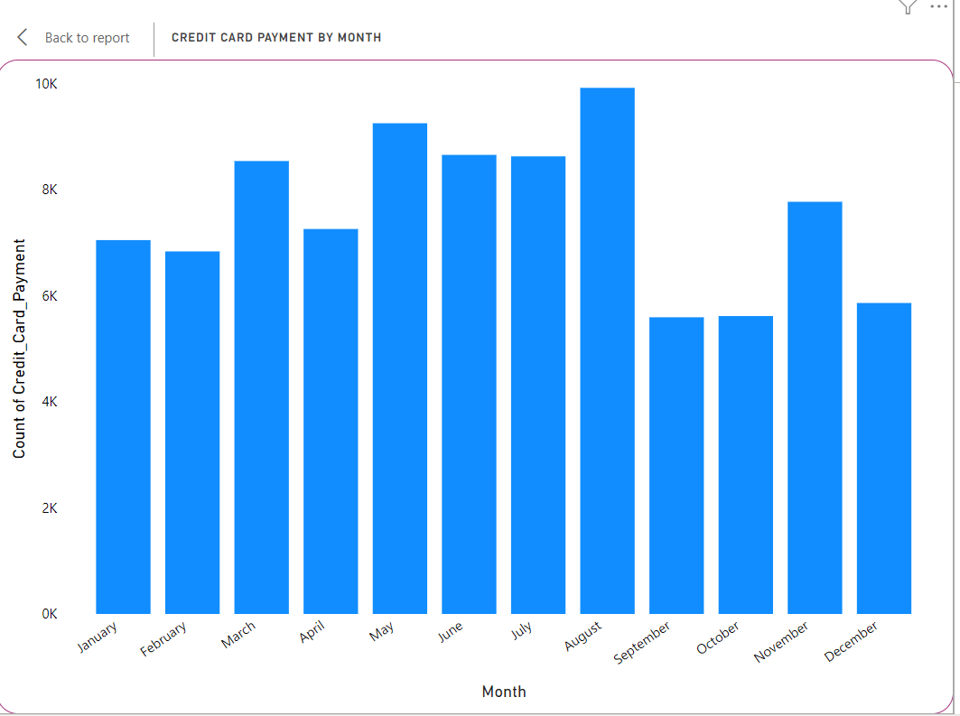

**Credit card payment by month**

In this question, I have transform the shipping_limit_date from text to date format and I have created a new column in which I select only the credit card payment and in visualizations in x-axis shipping_limit_date of month and y-axis count of credit card payment and I used Stacked column chart.

7. Identify sellers categorized by city, excluding cities starting with the letters S and B.

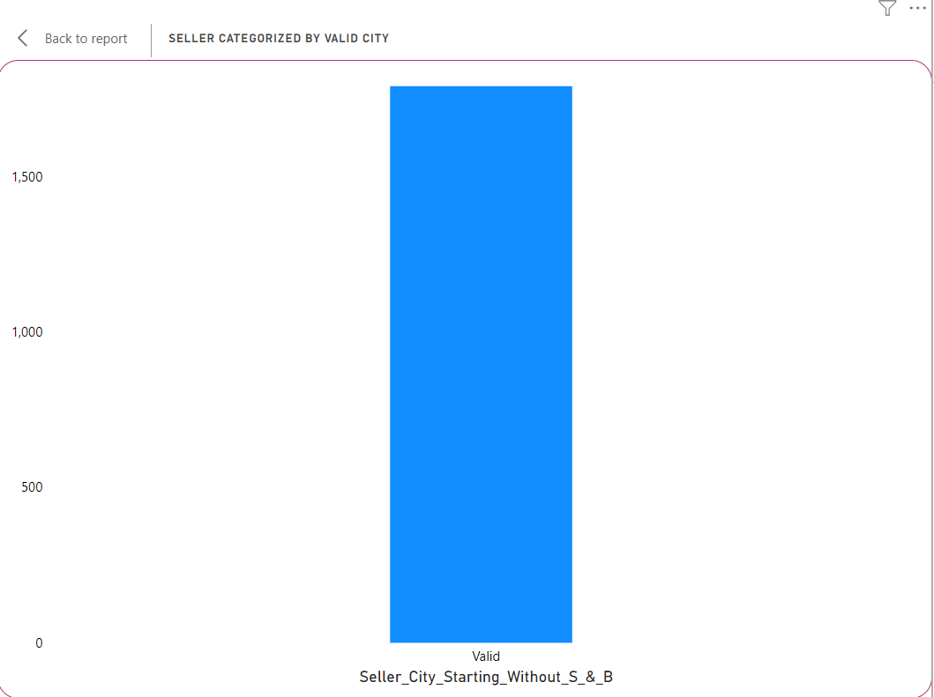

**Seller categorized by valid city**

In this question, I have used Nexusgoods_orders_dataset where I created a new column Seller_city_starting_without_S_&_B where I used if conditional loop

Seller_City_Starting_Without_S_&_B = IF(

    NOT(LEFT([seller_city], 1) IN {"S", "B"}),

    "Valid",

    "Invalid"

)

And in visualizations in x-axis Seller_city_starting_without_S_&_B and y-axis count of seller id and in chart I have used stacked column chart.

8.Create a dynamic visual that compares the number of delayed orders to the number of orders received earlier for each month. Utilize the drill through the cross-report feature to provide a detailed analysis of late and on-time deliveries.

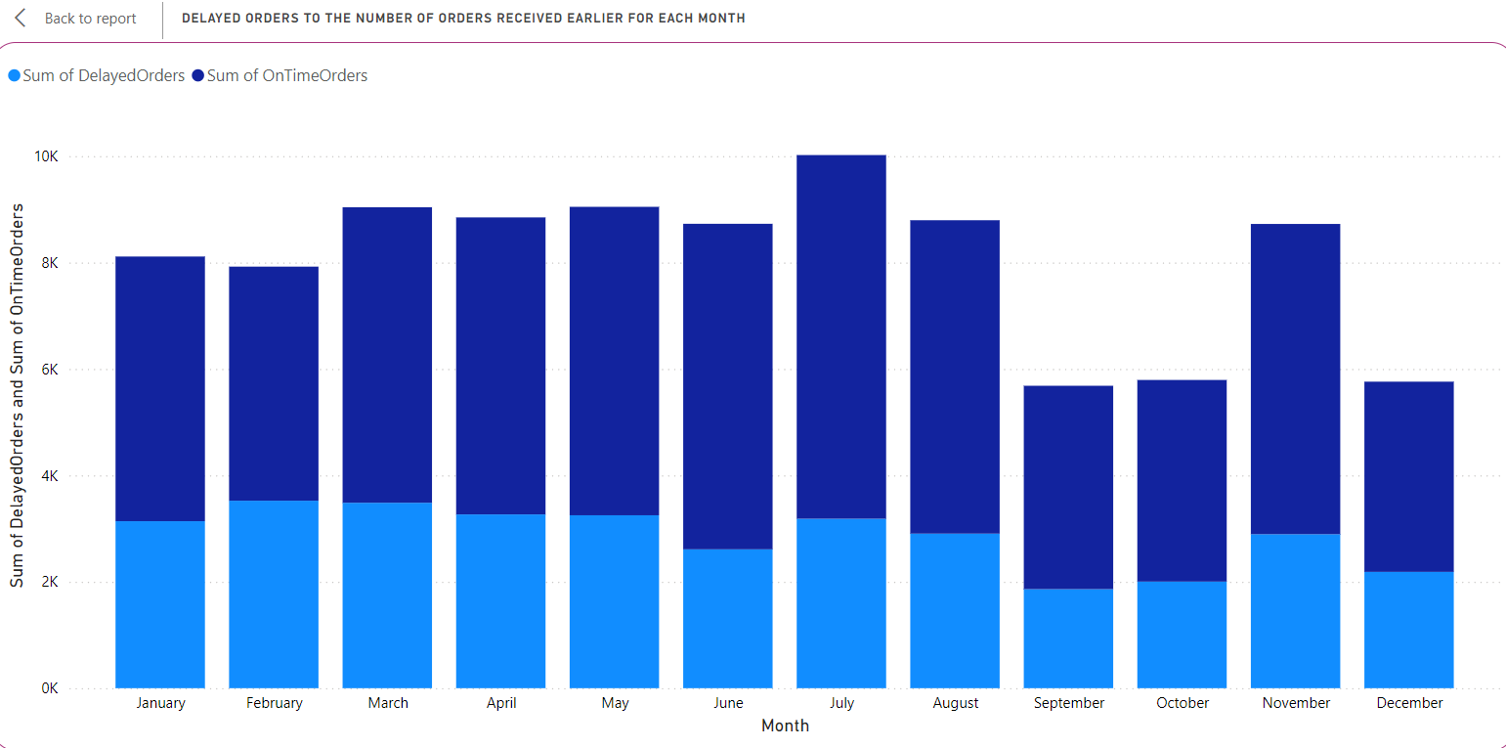

**Delayed orders to the number of orders received for each month**

In this question ,I have created a new dataset monthly summary dataset where I have used a formula to summarize the on time orders and delayed orders and I have used Stacked column chart.